EXPERIMENT – 8:
LAPLACE TRANSFORM, INVERSE TRANSFORM, ROC AND STABILITY

OBJECTIVES :
(i) To determine the inverse Laplace transform of a given frequency-domain representation and reconstruct the corresponding time-domain signal.
(ii) To determine the Region of Convergence (ROC) of Laplace transforms and analyze its significance in characterizing continuous-time signals and systems.

MATLAB CODING :
clc; clear; close all;
%% 8(ii) Determination of Inverse Laplace Transform for Signal Reconstruction
figure;
% Inverse Laplace Transform
% Requires Symbolic Math Toolbox
syms s t
X = 1/((s+2)*(s+3));
x = ilaplace(X,s,t);
disp('Inverse Laplace Transform x(t) =');
pretty(x);
tt = 0:0.001:5;
xx = double(subs(x,t,tt));
plot(tt,xx,'LineWidth',1.2);
grid on;
xlabel('Time (s)');
ylabel('Amplitude');
title('Signal Reconstructed using Inverse Laplace Transform');

MATLAB CODING :
clc; clear; close all;
%% 8(iii ) Analysis of Region of Convergence (ROC) and Its Significance in System
Analysis
figure;
% ROC Analysis for a Rational Laplace Transform
% Requires Symbolic Math Toolbox
% X(s) = 1/((s+2)(s+4))
% Poles are at s = -2 and s = -4.
p = [-2 -4];
plot(real(p),imag(p),'rx','MarkerSize',10,'LineWidth',2);
hold on;
xline(-2,'--'); xline(-4,'--');
grid on;
xlabel('Real(s)'); ylabel('Imag(s)');
title('Poles and Candidate Regions of Convergence');
legend('Poles','Pole at -2','Pole at -4');
fprintf('Poles are at s = -2 and s = -4.\n');
fprintf('For a right-sided signal, ROC: Re(s) > -2.\n');

fprintf('For a left-sided signal, ROC: Re(s) < -4.\n');
fprintf('For a two-sided signal, ROC: -4 < Re(s) < -2.\n');

OUTPUT :
To determine the inverse Laplace transform of a given frequency-domain representation and reconstruct the corresponding time-domain signal.
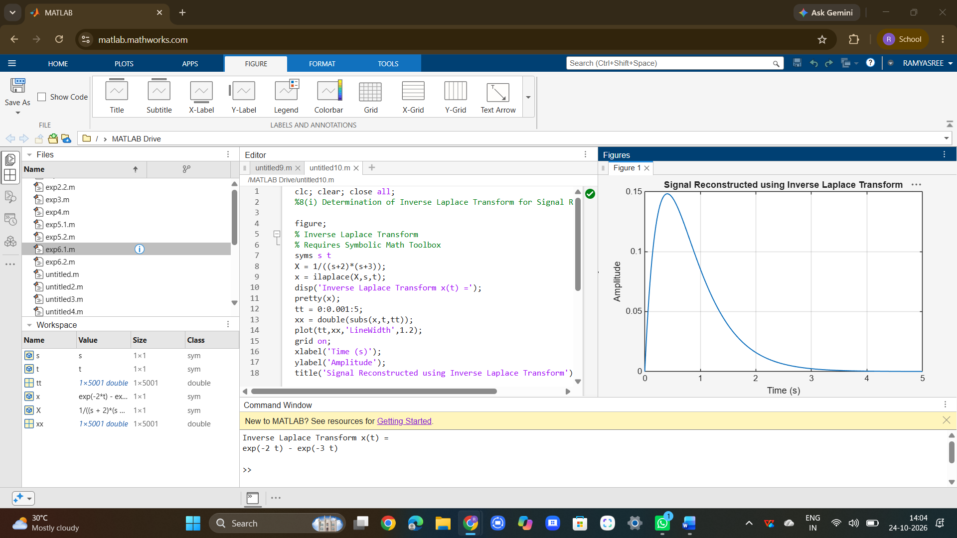

To determine the Region of Convergence (ROC) of Laplace transforms and analyze its significance in characterizing continuous-time signals and systems.
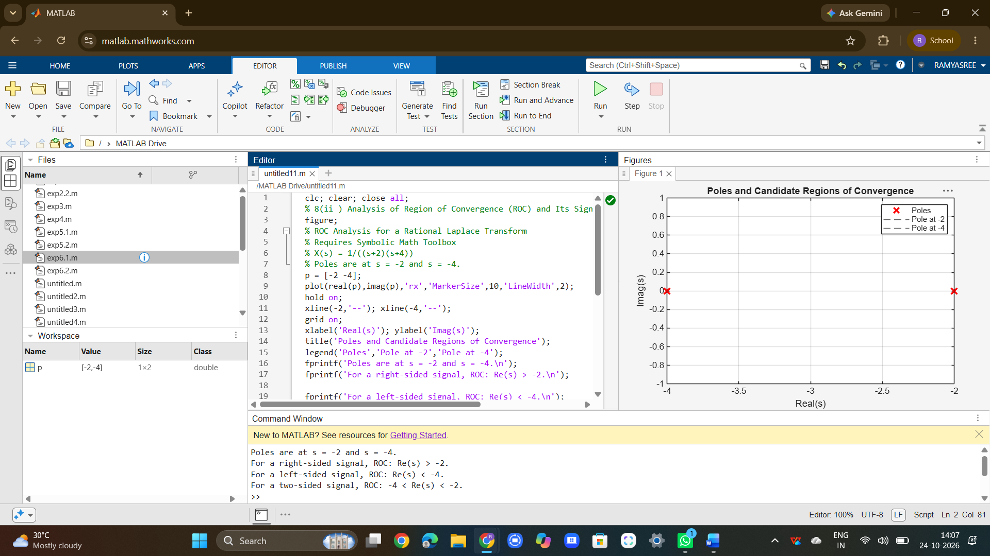

RESULT :
Thus, the inverse Laplace transform was determined to reconstruct the corresponding time-domain signal. The Region of Convergence (ROC) was identified, and its significance in analyzing continuous-time signals and system stability was studied successfully.

